Homework 2

Name: Chakrya Ros

Part 1: Date Model

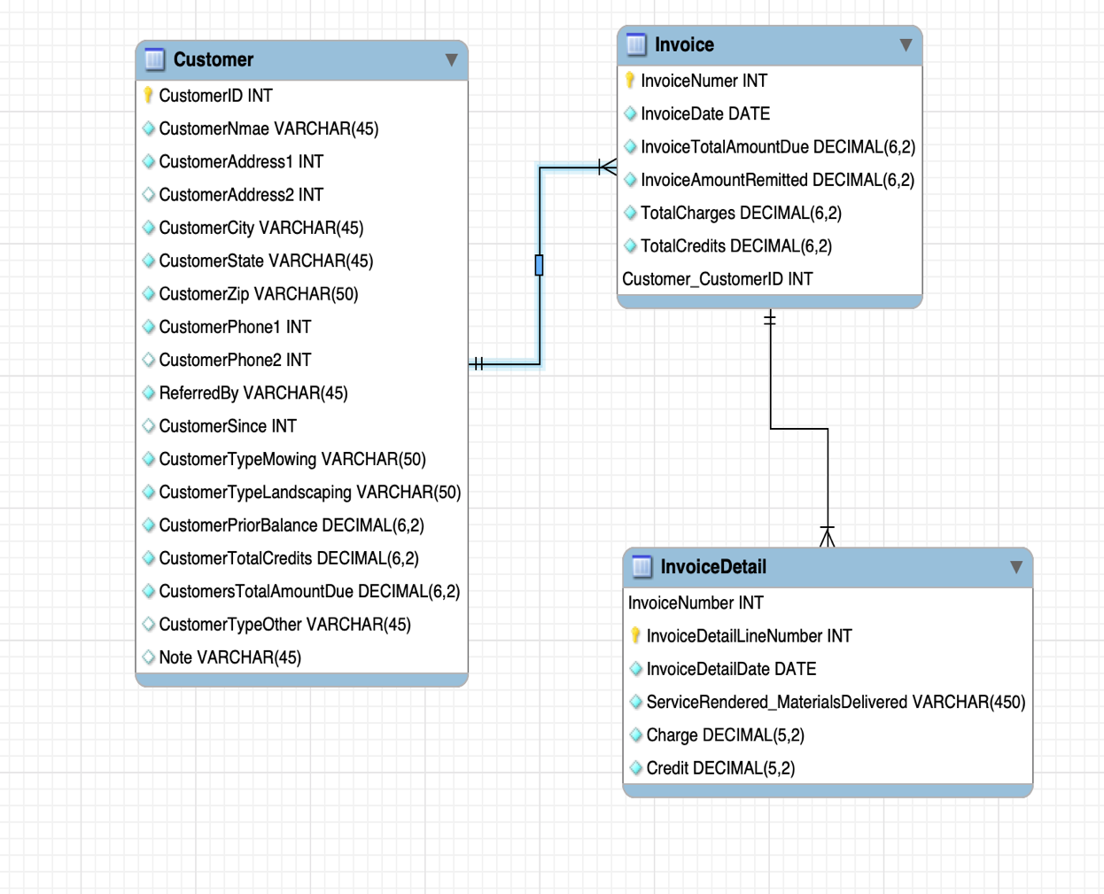

Part 2: DDL Scripts

-- MySQL Script generated by MySQL Workbench

-- Sat Feb 16 15:21:15 2019

-- Model: New Model Version: 1.0

-- MySQL Workbench Forward Engineering

SET @OLD_UNIQUE_CHECKS=@@UNIQUE_CHECKS, UNIQUE_CHECKS=0;

SET @OLD_FOREIGN_KEY_CHECKS=@@FOREIGN_KEY_CHECKS, FOREIGN_KEY_CHECKS=0;

SET @OLD_SQL_MODE=@@SQL_MODE, SQL_MODE='ONLY_FULL_GROUP_BY,STRICT_TRANS_TABLES,NO_ZERO_IN_DATE,NO_ZERO_DATE,ERROR_FOR_DIVISION_BY_ZERO,NO_ENGINE_SUBSTITUTION';

-- -----------------------------------------------------

-- Schema homework2

-- -----------------------------------------------------

-- -----------------------------------------------------

-- Schema homework2

-- -----------------------------------------------------

CREATE SCHEMA IF NOT EXISTS `homework2` DEFAULT CHARACTER SET utf8 ;

USE `homework2` ;

-- -----------------------------------------------------

-- Table `homework2`.`Customer`

-- -----------------------------------------------------

DROP TABLE IF EXISTS `homework2`.`Customer` ;

CREATE TABLE IF NOT EXISTS `homework2`.`Customer` (

`CustomerID` INT NOT NULL AUTO_INCREMENT,

`CustomerNmae` VARCHAR(45) NOT NULL,

`CustomerAddress1` INT NOT NULL,

`CustomerAddress2` INT NULL,

`CustomerCity` VARCHAR(45) NOT NULL,

`CustomerState` VARCHAR(45) NOT NULL,

`CustomerZip` VARCHAR(50) NOT NULL,

`CustomerPhone1` INT NOT NULL,

`CustomerPhone2` INT NULL,

`ReferredBy` VARCHAR(45) NOT NULL,

`CustomerSince` INT NULL,

`CustomerTypeMowing` VARCHAR(50) NOT NULL,

`CustomerTypeLandscaping` VARCHAR(50) NOT NULL,

`CustomerPriorBalance` DECIMAL(6,2) NOT NULL,

`CustomerTotalCredits` DECIMAL(6,2) NOT NULL,

`CustomersTotalAmountDue` DECIMAL(6,2) NOT NULL,

`CustomerTypeOther` VARCHAR(45) NULL,

`Note` VARCHAR(45) NULL,

PRIMARY KEY (`CustomerID`))

ENGINE = InnoDB;

-- -----------------------------------------------------

-- Table `homework2`.`Invoice`

-- -----------------------------------------------------

DROP TABLE IF EXISTS `homework2`.`Invoice` ;

CREATE TABLE IF NOT EXISTS `homework2`.`Invoice` (

`InvoiceNumer` INT NOT NULL AUTO_INCREMENT,

`InvoiceDate` DATE NOT NULL,

`InvoiceTotalAmountDue` DECIMAL(6,2) NOT NULL,

`InvoiceAmountRemitted` DECIMAL(6,2) NOT NULL,

`TotalCharges` DECIMAL(6,2) NOT NULL,

`TotalCredits` DECIMAL(6,2) NOT NULL,

`Customer_CustomerID` INT NOT NULL,

PRIMARY KEY (`InvoiceNumer`, `Customer_CustomerID`),

INDEX `fk_Invoice_Customer1_idx` (`Customer_CustomerID` ASC) VISIBLE,

CONSTRAINT `fk_Invoice_Customer1`

FOREIGN KEY (`Customer_CustomerID`)

REFERENCES `homework2`.`Customer` (`CustomerID`)

ON DELETE NO ACTION

ON UPDATE NO ACTION)

ENGINE = InnoDB;

-- -----------------------------------------------------

-- Table `homework2`.`InvoiceDetail`

-- -----------------------------------------------------

DROP TABLE IF EXISTS `homework2`.`InvoiceDetail` ;

CREATE TABLE IF NOT EXISTS `homework2`.`InvoiceDetail` (

`InvoiceNumber` INT NOT NULL,

`InvoiceDetailLineNumber` INT NOT NULL AUTO_INCREMENT,

`InvoiceDetailDate` DATE NOT NULL,

`ServiceRendered_MaterialsDelivered` VARCHAR(450) NOT NULL,

`Charge` DECIMAL(5,2) NOT NULL,

`Credit` DECIMAL(5,2) NOT NULL,

PRIMARY KEY (`InvoiceNumber`, `InvoiceDetailLineNumber`),

CONSTRAINT `fk_InvoiceDetail_Invoice`

FOREIGN KEY (`InvoiceNumber`)

REFERENCES `homework2`.`Invoice` (`InvoiceNumer`)

ON DELETE NO ACTION

ON UPDATE NO ACTION)

ENGINE = InnoDB;

SET SQL_MODE=@OLD_SQL_MODE;

SET FOREIGN_KEY_CHECKS=@OLD_FOREIGN_KEY_CHECKS;

SET UNIQUE_CHECKS=@OLD_UNIQUE_CHECKS;

Part 3: Assumption & Thought Process

1. I had to assume that customers has multiple possible invoices, so I used an independent one to many relationship between Customers and invoice.
2. Invoice are composed of invoice details, so I used a dependent one to many.
3. Customer ID is the foreign key of Invoice table and the InvoiceNumber is foreign key of InvoiceDetail table .